INFANT

6 weeks – 18 months
7:00 a.m. – 5:45 p.m.
ANNUAL TUITION: $11,400.

Payment Due Amount
1 September 3 $950.00
2 October 1 950.00
3 November 1 950.00
4 December 2 950.00
5 January 6 950.00
6 February 3 950.00
7 March 3 950.00
8 April 1 950.00
9 May 1 950.00
10 June 2 950.00
11 July 1 950.00
12 August 1 950.00

TODDLER
19 months – 36 months
7:00 a.m. – 5:45 p.m.
ANNUAL TUITION: $10,800.
Payment Due Amount
1 September 3 $900.00
2 October 1 900.00
3 November 1 900.00
4 December 2 900.00
5 January 6 900.00
6 February 3 900.00
7 March 3 900.00
8 April 1 900.00
9 May 1 900.00
10 June 2 900.00
11 July 1 900.00
12 August 1 900.00

PRESCHOOL/KINDERGARTEN
(3 to 6 years)
Half –Day Classes
9:00 a.m. – 11:30 a.m. or 1:00 p.m. – 3:30 p.m.
TUITION: $4970.

Payment Due Amount
1 with application $200.00
2 September 3 530.00
3 October 1 530.00
4 November 1 530.00
5 December 2 530.00
6 January 6 530.00
7 February 3 530.00
8 March 3 530.00
9 April 1 530.00
10 May 1 530.00

Full Day Classes
9:00 a.m. – 3:30 p.m.
TUITION: $6,500.

Payment Due Amount
1 with application $200.00
2 September 3 700.00
3 October 1 700.00
4 November 1 700.00
5 December 2 700.00
6 January 6 700.00
7 February 3 700.00
8 March 3 700.00
9 April 1 700.00
10 May 1 700.00

Extended Day Classes
7:00 a.m. – 5:45 p.m.
TUITION: $7,490.

Payment Due Amount
1 with application $200.00
2 September 3 810.00
3 October 1 810.00
4 November 1 810.00
5 December 2 810.00
6 January 6 810.00
7 February 3 810.00
8 March 3 810.00
9 April 1 810.00
10 May 1 810.00

Application fees:
Infant / Toddler - $100.00
New students - $300.00
Returning students: Before April 1 - $250.00
After April 1 - $300.00 (if openings are still available)

$200.00 of the application fees are payment # 1
All application fees, including first $200.00, are non-refundable and payable when submitting application for admission.

Second and/or additional children from the same family receive a 10% discount off tuition. The discount will be taken from the lowest tuition received. Due to staffing requirements, there are no discounts for the infant or toddler program.

Pre-Payment of tuition: Annual payment – 4% discount

LATE PAYMENTS: A $30.00 late fee will be added each week tuition is more than five days past due.

NSF CHECKS: A fee of $25.00 will be charged for each check that is returned from the bank as NSF or otherwise uncollected.

LATE PICK UP: We are licensed by the State of Michigan Department of Human Services. Our hours of operation are 7:00 am – 6:00 pm. After school pick up time is no later than 5:45 pm. Any child remaining in the building after 6:00 pm is subject to a $5.00 per minute late fee. These charges will be billed separately.

We accept cash, checks and money orders. You may also authorize your financial institution, through online banking, to make automatic payments directly to the school. If interested, check with your financial institution for more information.

Before and/or after school care is available for children who need to stay on an occasional basis. Fees are due at the end of each month and are billed as used. The fee is $5.00 per hour or portion thereof.

There is no reduction, discount or credit for snow days, teacher conference/record/in service days, student’s absence, or vacation, acts of nature or holiday breaks.

Vacation periods are governed by the Melvindale-Northern Allen Park Schools calendar.

MISSION STATEMENT

We at Montessori Children’s Center strive to adhere to the philosophy of Dr. Maria Montessori. We believe that every child should have the opportunity to reach their full potential and be treated with kindness and respect in his or her environment. We are dedicated to the preparation of the child for a life of academic achievement by providing a quality, personalized learning experience in a nurturing atmosphere. By valuing the spirituality and uniqueness of each individual and with gentle direction and guidance, we believe each child will progress with confidence.
********

Our infant and toddler fees are based on a year-round schedule, beginning the Tuesday after Labor Day, and ending the third or fourth week of August. All pre-scheduled vacations and holidays have been accounted for.

The preschool, kindergarten and elementary fees are based on a nine-month school year, beginning the Tuesday after Labor Day, and ending in mid-June.

We do offer an excellent summer program filled with day camps and workshops. Summer brochures are available in early March.

All classes are Monday through Friday.

- “The greatest sign of success for a teacher…is to be able to say, “The children are now working as if I did not exist.”
- Maria Montessori

2024/25
TUITION SCHEDULE

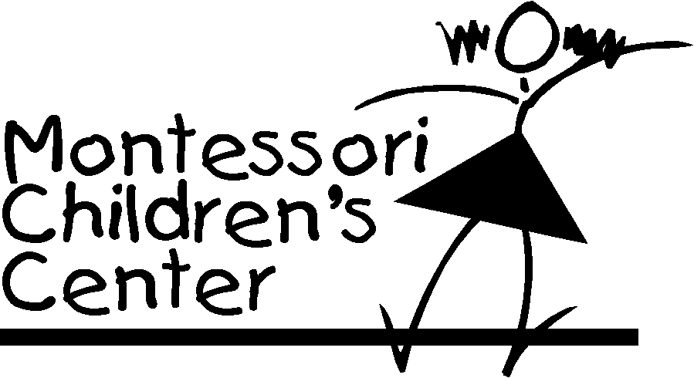

4141 Laurence Street
Allen Park, Michigan 48101
313-382-2777

FAX 313-382-4838

www.montessorichildcenter.com
email: montessorichildcenterallenpark@gmail.com

