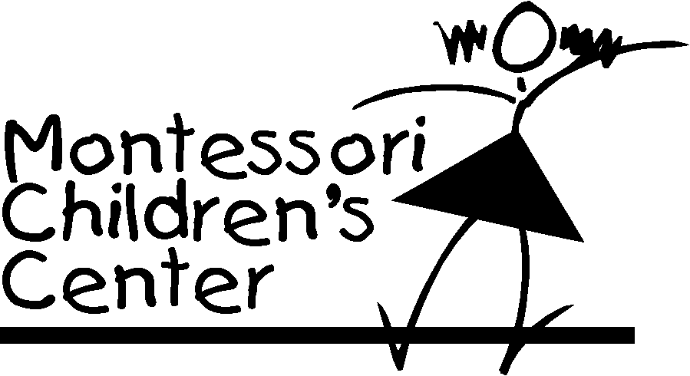

Our school offers physical education classes every week. All students, ages 18 months through kindergarten will meet a minimum of one day per week.

For the safety of your child, we require either tennis shoes or a shoe with a rubber sole that tie or has Velcro fastenings, be worn. Boots or dress shoes of any kind will not be permitted on the Gym floor. We also request that your child wear clothing that will enable them to participate in physical activities.

The form below will also make us aware of any physical limitations your child may have. Please comment on any problem that would hinder your child’s performance in Physical Education class.

This form will serve as permission for your child to participate as long as your child is enrolled at Montessori Children’s Center of Allen Park. It is the responsibility of the parent/guardian signing this form to notify us of any changes in your child’s ability to participate in physical education classes.

Sign, date and return with Admission application.

Child’s name ____________________________________________________________

I understand that my child will not be allowed to participate in Physical Education class without proper shoes and attire.

Limitations we should be aware of:
________________________________________________________________________ ________________________________________________________________________
________________________________________________________________________
________________________________________________________________________

Parent Signature Date

031223

